**PRIVACY POLICY**

**RALOC TRAVELS PRIVACY POLICY: HOW DO WE COLLECT DATA?**   
  
All of the information pertaining to a traveler's booking, request, trip, or tour is securely gathered by email and stored in our database whenever a traveler or an agent contacts us on behalf of their client.

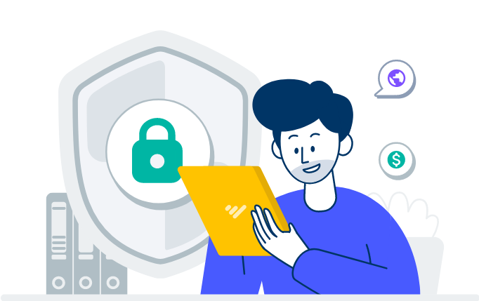

**WHY AND WHAT DATA DO WE COLLECT?**

The following information may be gathered throughout the account registration and booking process:

* Individual Data
* Address of Residence
* Details of the National ID card and postal address
* Details about the family
* Information for Education
* Work Experience
* Details about the parent or parents
* Subsequent KIN Details

When a registration or inquiry is made When a registration or inquiry is made   
  
Our suppliers need the booking name (first name, middle/other names, and last name) in order to hold a temporary reservation.

Nationality: to inform visitors of any visa needs for the places they intend to visit   
  
Children's ages: to make sure our advisers recommend activities and accommodations that are age-appropriate and provide discounted prices when kid discounts are available. Travelers' hobbies, budget, and any other private information they choose to provide to their agent can help us make recommendations for their vacation.

**When the confirmation was made**   
  
Tours are not without their inherent risks. It is advised that we have the personal information of every visitor on hand in case of an emergency, as we are the first point of contact on the ground. For operational and legal reasons, several of our service providers also need this information when confirming a reservation. We risk compromising our emergency response time if you decide not to share this information with us. To handle any emergencies that might occur while travel or a tour, the following details are needed;

Complete name (last name, middle or other names, and first name)   
Details of the passport (nationality and number)   
Details of Medical Insurance (policy number, emergency contact number, and insurance company)   
Next of Kin (Contact information for emergencies)   
allergies or pre-existing medical conditions

Additional information, such as weight, birthday, and special dietary needs, could be needed to guarantee the comfort and convenience of travelers during their trip.   
  
**WHO DO WE GIVE THIS INFORMATION TO?**

Raloc Travels primarily uses the data that is given to us for the purposes for which it was collected. This includes organizing and scheduling travel and tour plans for our customers and handling any emergencies that may come up while they are traveling. In the event that a third party is handling the program on our behalf, we only give them access to the data they need to plan our travel and tour plans.

When a booking is confirmed, this information will be shared with the appropriate subcontractors (local lodging, transportation, and activity providers) as needed to guarantee our clients' comfort and safety while traveling and to make sure all plans are made. As needed and judged necessary by top management, this information may be shared in an emergency with emergency response teams, law enforcement, government representatives, etc.

**CLIENT COMMENTS**

Service providers will receive feedback so they can resolve any issues and provide credit where credit is needed. In order to improve consultants' understanding of the destination, product, and/or client expectations, feedback will also be shared internally within our reservations department.   
  
**WHAT IS THE DURATION OF DATA KEEP?**

After a trip, customer information forms are retained for a full year. For up to two years following travel, more generic details about the reservation procedure might be retained on file.   
  
**WHOM TO CONTACT**Please email us at ralocgh@gmail.com, or give us a call at 0503905535, if you have any questions or concerns about how we secure your data.